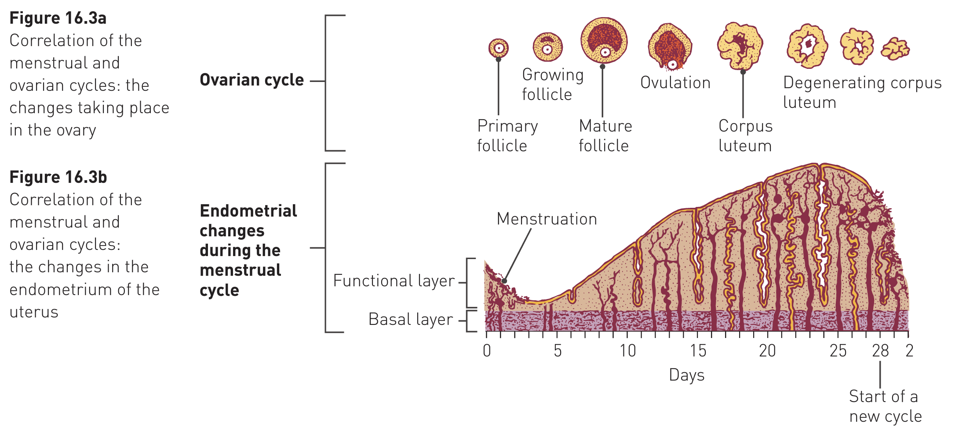
Menstrual Cycle
- Whilst the ovarian cycle takes place, another cycle of changes occurs in the uterus, and to a lesser extent, the vagina – the menstrual cycle
- A cycle where changes in the lining of the uterus are closely associated with stages in the ovarian cycle
- The changes in the uterine lining, the endometrium, are in preparation for a developing embryo in case the egg released at ovulation is fertilised
- When the embryo reaches the uterus, it has to implant itself in the endometrium

- In first stage of the ovarian cycle (period where follicle is maturing) the endometrium of the uterus becomes thicker and softer
- Increase in the number of blood vessels and mucus-secreting glands
- After ovulation the endometrium continues to thicken, and glands within begin to secrete w a watery mucus rich in glycogen

- If egg isn’t fertilised by sperm, the corpus luteum degenerates, reducing amount of hormone influencing build-up of the endometrium, resulting in its breakdown
- ~14 days after ovulation, blood from broken-down capillaries, mucous secretions and cell debris from the uterine lining are lost through the vagina – menstruation
- Menstruation takes place over several days and is commonly referred to as the menstrual period (or just period)
- Most recognisable point in the menstrual cycle, the onset of menstruation is taken to be day 1 of the cycle

STAGE | DAYS | EVENTS
Menstruation | 1-4 | Uterine bleeding, accompanied by shredding of endometrium
Preovulation | 5-12 | Endometrial repair begins; development of ovarian follicle; uterine lining gradually thickens
Ovulation | 12-15 | Rupture of mature follicle, releasing egg
Secretion | 16-20 | Secretion of water mucus by glands of endometrium, cervix and uterine tubes; movement and breakdown of unfertilised egg; development of corpus luteum
Premenstruation | 21-28 | Degeneration of corpus luteum, deterioration of endometrium

- When menstruation initially begins, it is called menarche
- Marks the commencement of puberty
- From that time, a female will have a menstrual cycle about once a month unless interrupted by pregnancy
- The cycles last until menopause
- Menopause is the time when the processes that occurred at puberty are reversed
- Usually begins between ages of 45-55
- Takes place over a period of years, during which time the menstrual cycle becomes irregular until it eventually ceases
- Usually a woman has a potential of about 35 child-bearing years, and in most women about 400 of the initial 400,000 potential eggs reach maturity

